**PLUGGING INTO THE FUTURE: AN EXPLORATION OF THE ELECTRICITY CONSUMPTION PATTERNS**

1. **INTRODUCTION**

**1.1 Overview**

India is the world's third-largest producer and third-largest consumer of electricity. The gross electricity consumption per capita in FY2019 was 1,208 kWh. In 2015-16, electric energy consumption in agriculture was recorded as being the highest (17.89%) worldwide. In light of the recent COVID-19 situation, when everyone has been under lockdown for the months of March to June the impacts of the lockdown on economic activities have been faced by every sector in a positive or a negative way. The dataset is exhaustive in its demonstration of energy consumption state wise. Analysing Electricity Consumption in India from Jan 2019 till 5TH December 2020. The dataset contains a record of Electricity Consumption in each states in I9ndai, here I analysed Stats wise, Region Wise and Overall Electricity Consumption in India.

**1.2 Purpose**

The purpose of this project on the topic Plugging into future – An Exploration Of Electricity Consumption Patterns is to reduce Electricity Consumption all over India. That is, firstly I analysed the data of Electricity consumed all over the States, Regions of our country India. Then by analysing all the data of the usage of Electricity all over India we can get an idea how to reduce the Electricity Consumption of our country and to reduce the electricity waste of our country. Hence, Purpose of this project is to reduce the Electricity Consumption of our Country.

**2. Problem Definition & Design Thinking**

**2.1 Empathy Map**

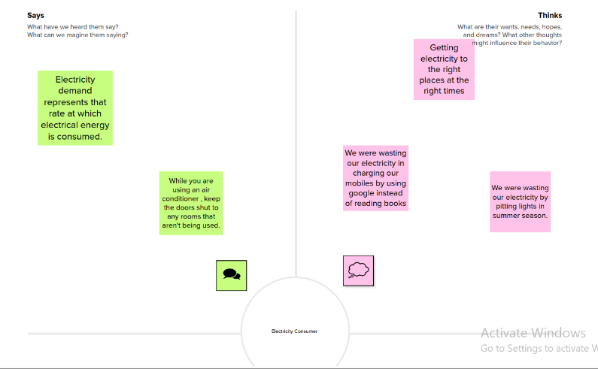

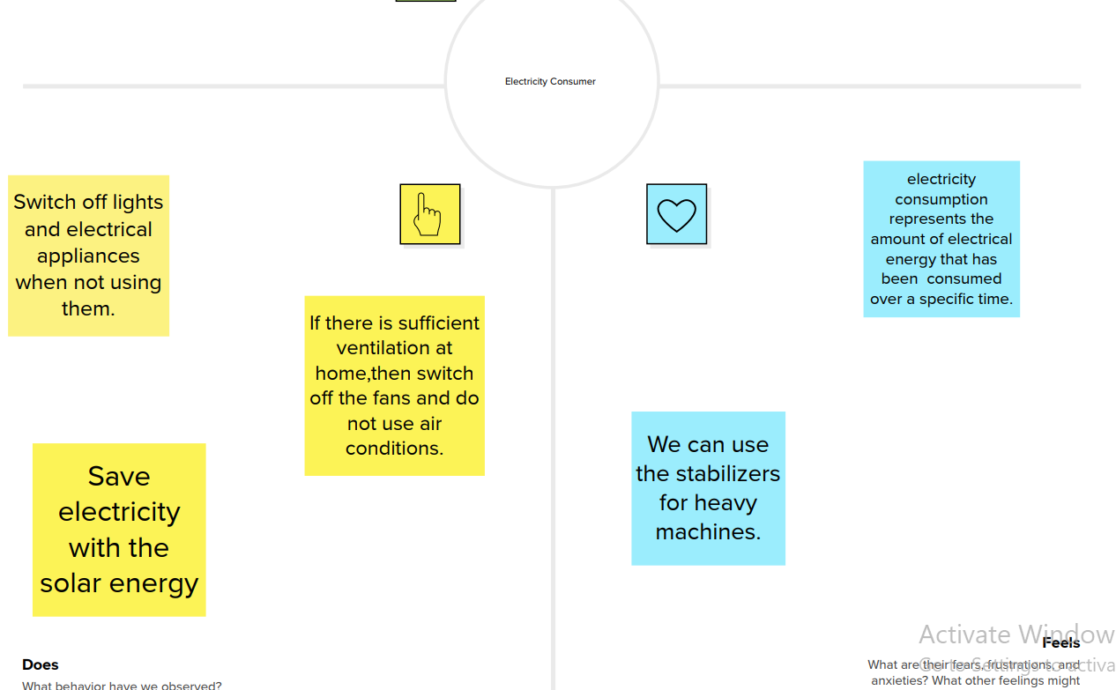

**2.2 Ideation & Brainstorming Map**

**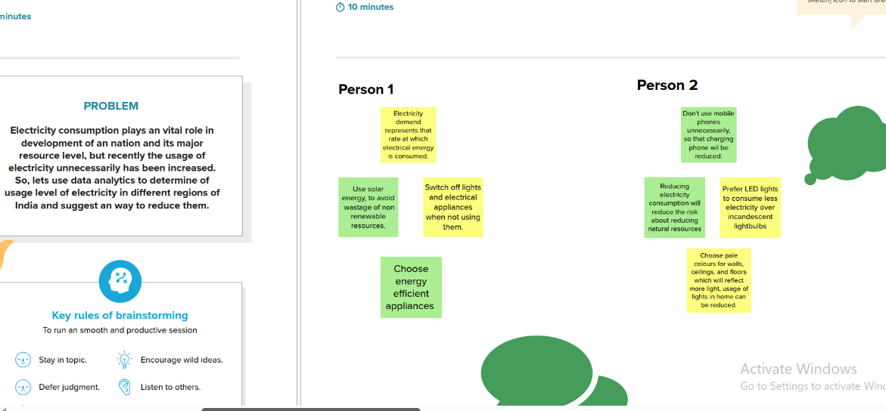   
 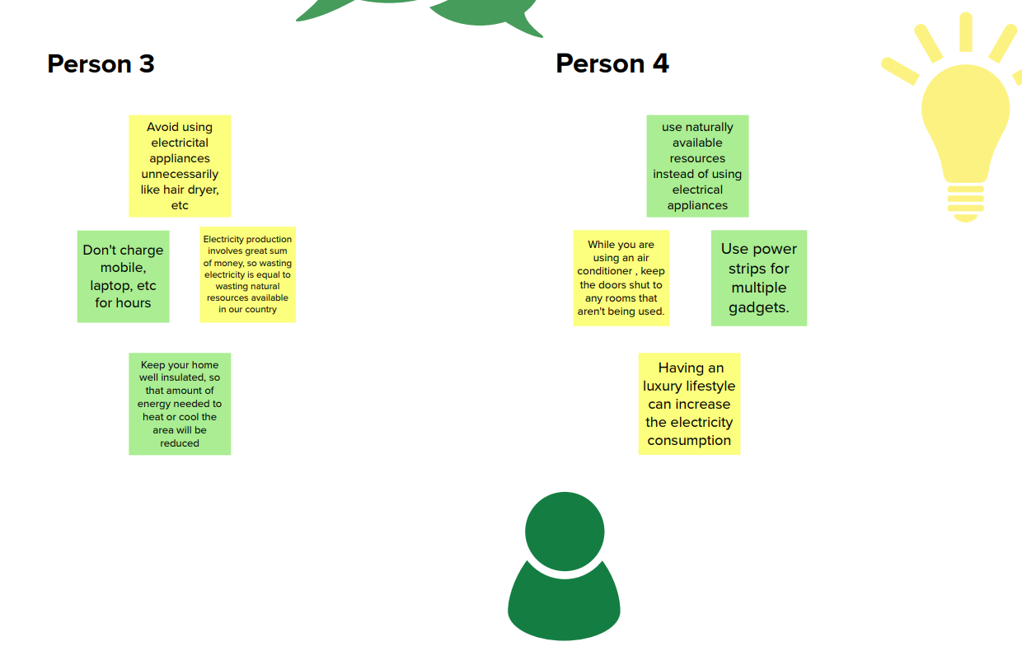**

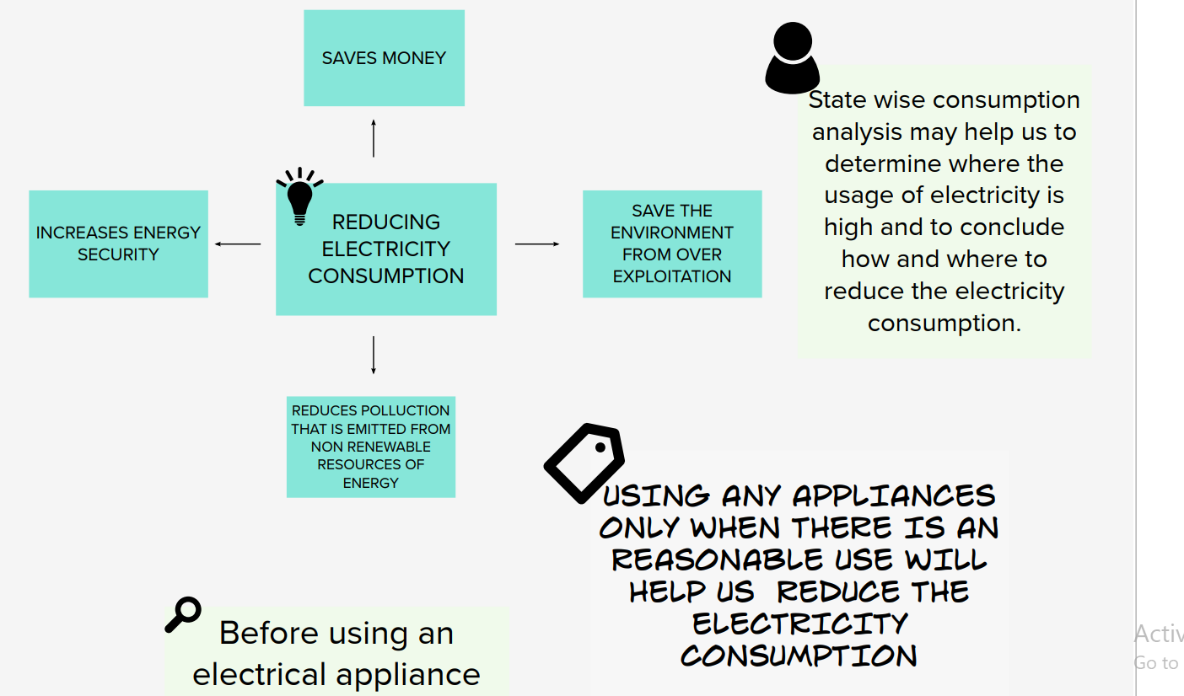

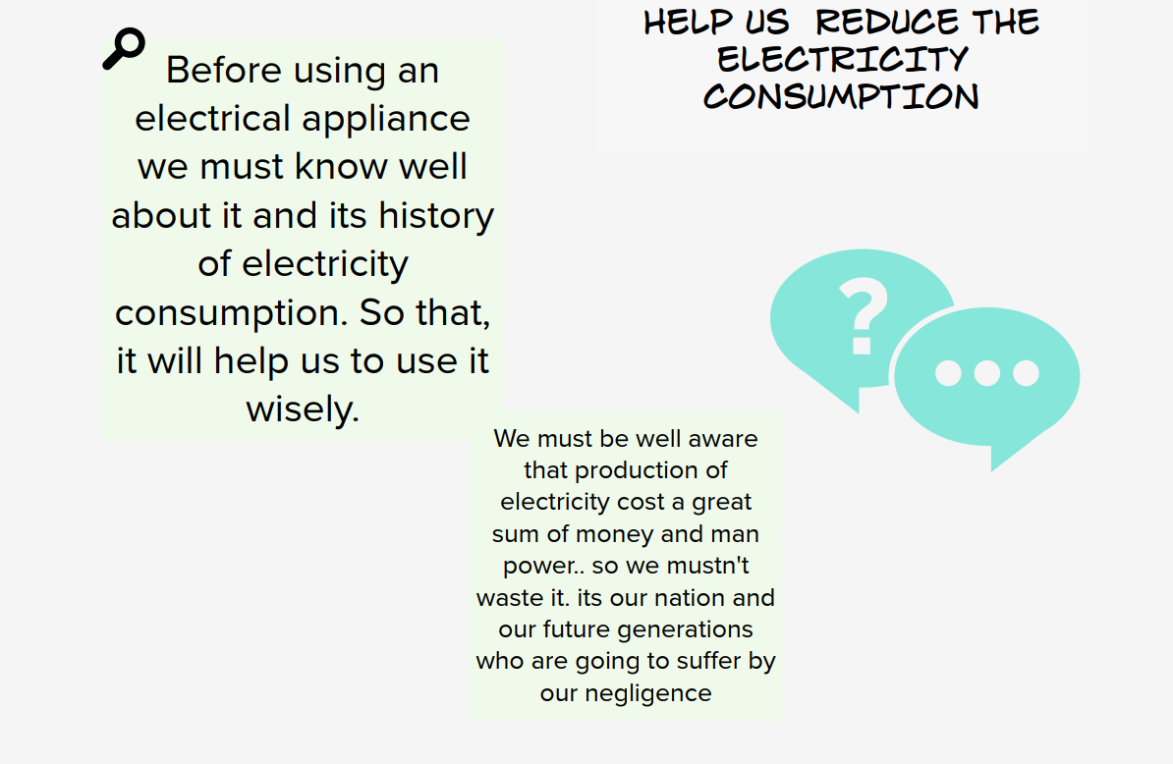

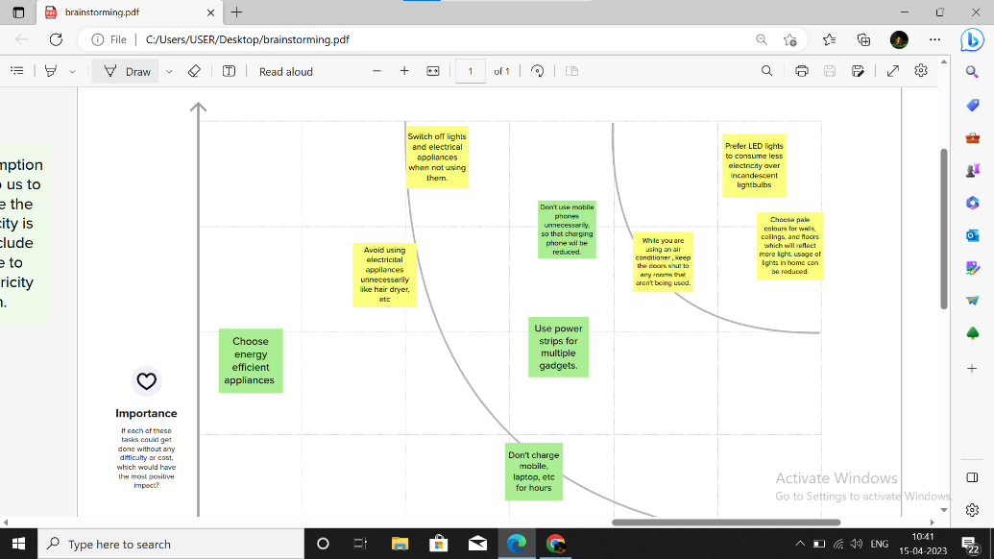

**3. Result**

The final output of this project is the analysis of Electricity consumption of India all over the States, Regions and also month wise consumption of the Electricity all states of the Country.

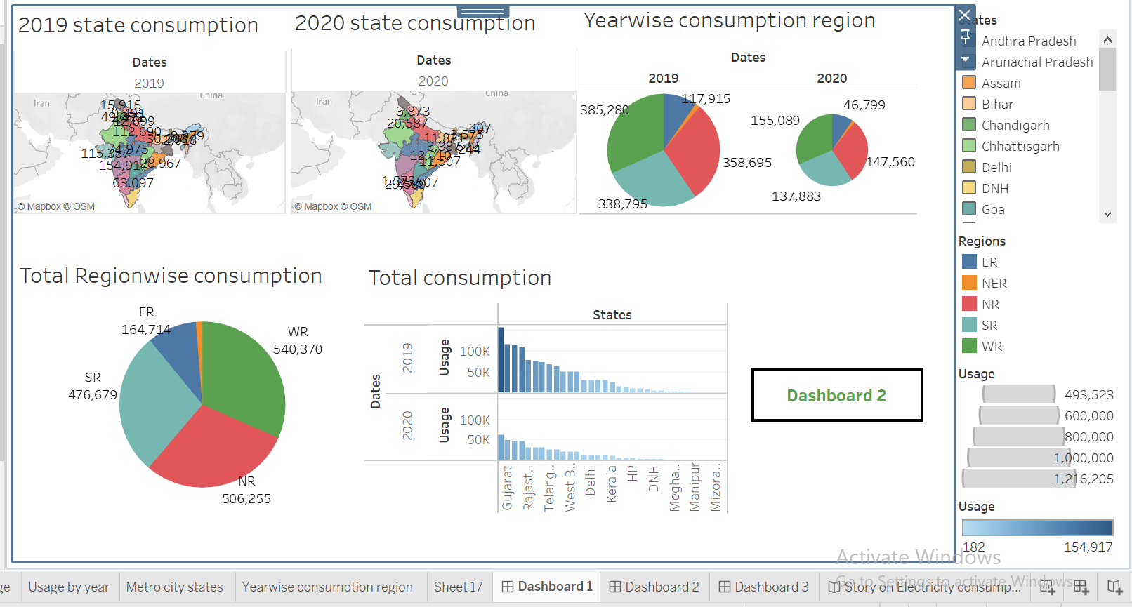

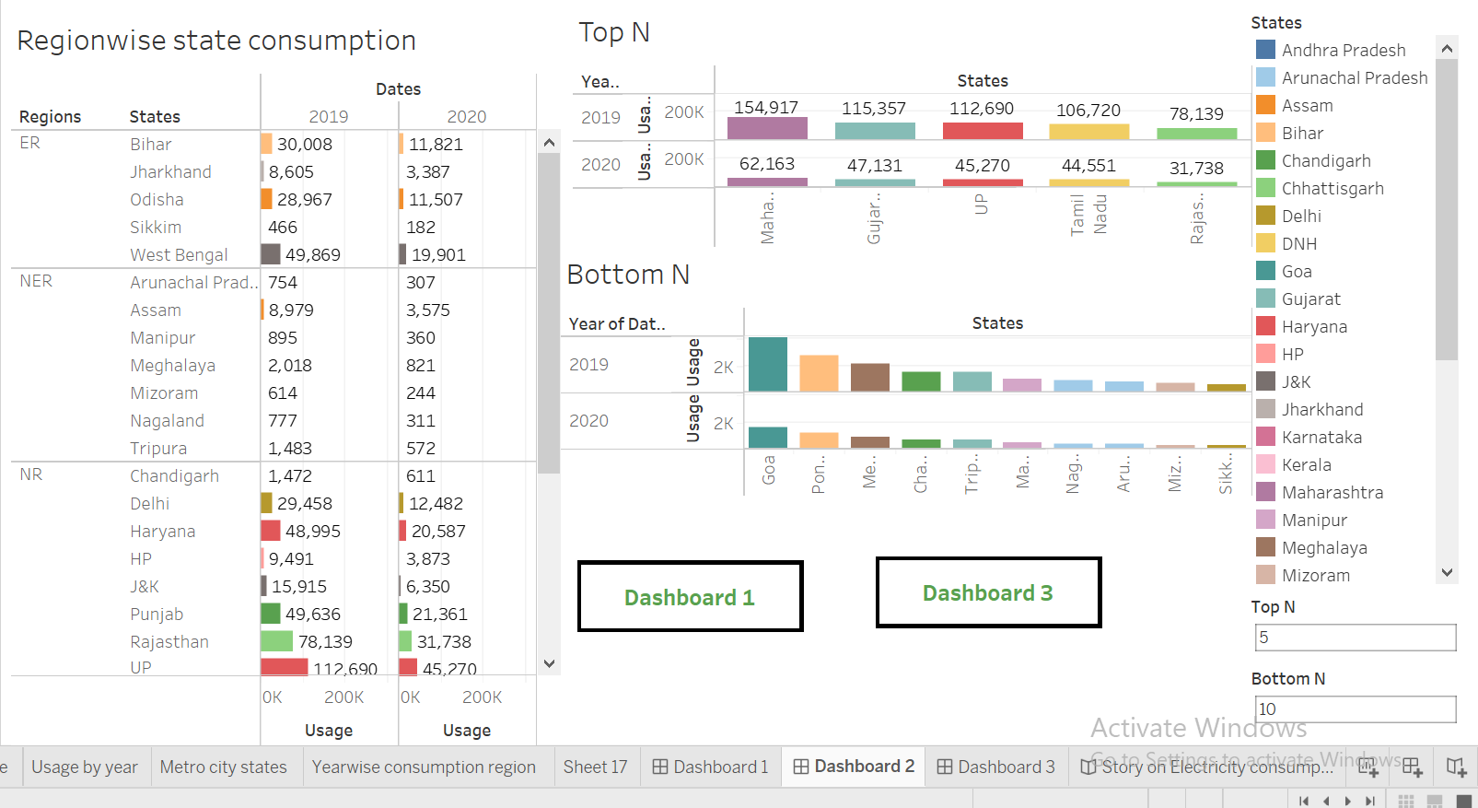

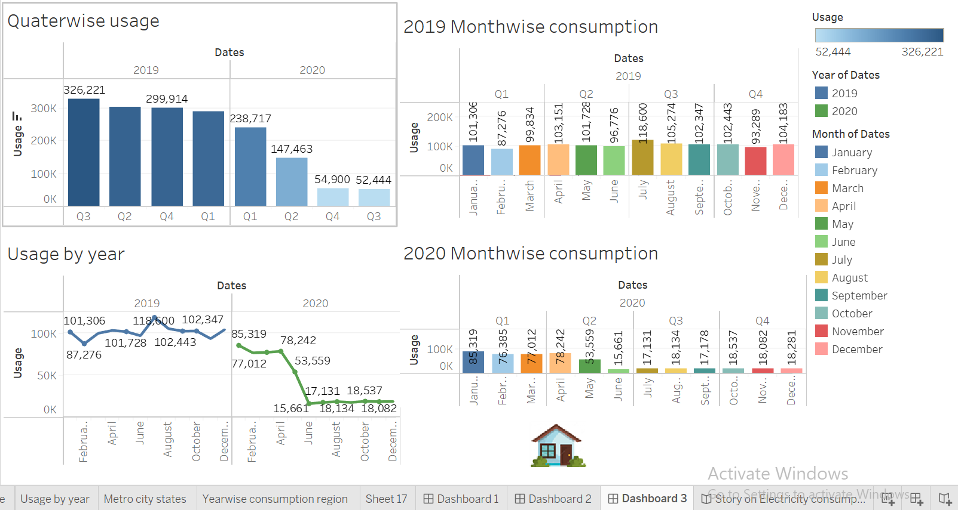

**4. Advantages & Disadvantages**

**By analysis the visuals the advantages are:**

* Firstly, by analysing the dataset we can reduce the electricity consumption in our country.
* Secondly, As compared to 2020 electricity consumption all over India is lower than 2019 consumption.
* Then, Region wise plot clearly states consumption in 2019 is more as compared to consumption in 2020.
* The most Electricity consumption 2019s highest in Western Region whereas NER has less consumption.
* Maharashtra has highest usage of Electricity and its peak on Q3 of 2019 and its lowest consumption is at Q4 of 2020.
* Electricity consumption of period March to June was less in 2020 as compared to 2019 as because of Lockdown

**By analysis the visuals the disadvantages are:**

* In 2019, the consumption of electricity in January is almost lower, but in 2020 it is in the highest place.
* In 2019, Electricity consumption was more as compared to 2020 in India.

**5. Applications**

* Getting electricity to the right places at the right times
* We were wasting our electricity in charging our mobiles by using google instead of reading books
* We were wasting our electricity by pitting lights in summer season.
* Switch off lights and electrical appliances when not using them.
* If there is suffcient ventilation at home, then switch off the fans and do not use air conditions.
* Save electricity with the solar energy
* We can use the stabilizers for heavy machines.
* Electricity consumption represents the amount of electrical energy that has been consumed over a specifc time.

**6. Conclusion**

Hence, by summarizing all my visuals, datasets and my findings, I conclude that we can reduce our country’s electricity consumption by following the applications and also by analysing the datas and visuals. Hence, we can reduce our electricity consumption by analysing datas.

**7. Future Scope**

* Smarter, more connected homes.
* Ultra-Efficient heat pumps.
* Carbon-Fighting clothes dryers.
* Magnetic refrigerators.
* Advanced window controls.
* Next-Gen insulation.
* Reflective roofing materials.
* Brighter, better lighting.

**8. Appendix**

**A. Source code**

For Book1 (html code)

<div class='tableauPlaceholder' id='viz1681548501363' style='position: relative'><noscript><a href='#'><img alt='Dashboard 1 ' src='https:&#47;&#47;public.tableau.com&#47;static&#47;images&#47;Bo&#47;Book1_16813632973670&#47;Dashboard1&#47;1_rss.png' style='border: none' /></a></noscript><object class='tableauViz' style='display:none;'><param name='host_url' value='https%3A%2F%2Fpublic.tableau.com%2F' /> <param name='embed_code_version' value='3' /> <param name='site_root' value='' /><param name='name' value='Book1_16813632973670&#47;Dashboard1' /><param name='tabs' value='no' /><param name='toolbar' value='yes' /><param name='static_image' value='https:&#47;&#47;public.tableau.com&#47;static&#47;images&#47;Bo&#47;Book1_16813632973670&#47;Dashboard1&#47;1.png' /> <param name='animate_transition' value='yes' /><param name='display_static_image' value='yes' /><param name='display_spinner' value='yes' /><param name='display_overlay' value='yes' /><param name='display_count' value='yes' /><param name='language' value='en-US' /></object></div> <script type='text/javascript'> var divElement = document.getElementById('viz1681548501363'); var vizElement = divElement.getElementsByTagName('object')[0]; if ( divElement.offsetWidth > 800 ) { vizElement.style.width='100%';vizElement.style.height=(divElement.offsetWidth*0.75)+'px';} else if ( divElement.offsetWidth > 500 ) { vizElement.style.width='100%';vizElement.style.height=(divElement.offsetWidth*0.75)+'px';} else { vizElement.style.width='100%';vizElement.style.height='1827px';} var scriptElement = document.createElement('script'); scriptElement.src = 'https://public.tableau.com/javascripts/api/viz_v1.js'; vizElement.parentNode.insertBefore(scriptElement, vizElement); </script>

For story (html code)

<div class='tableauPlaceholder' id='viz1681548790460' style='position: relative'><noscript><a href='#'><img alt='Story on Electricity consumption in India ' src='https:&#47;&#47;public.tableau.com&#47;static&#47;images&#47;st&#47;story_16813635908410&#47;StoryonElectricityconsumptioninIndia&#47;1_rss.png' style='border: none' /></a></noscript><object class='tableauViz' style='display:none;'><param name='host_url' value='https%3A%2F%2Fpublic.tableau.com%2F' /> <param name='embed_code_version' value='3' /> <param name='site_root' value='' /><param name='name' value='story_16813635908410&#47;StoryonElectricityconsumptioninIndia' /><param name='tabs' value='no' /><param name='toolbar' value='yes' /><param name='static_image' value='https:&#47;&#47;public.tableau.com&#47;static&#47;images&#47;st&#47;story_16813635908410&#47;StoryonElectricityconsumptioninIndia&#47;1.png' /> <param name='animate_transition' value='yes' /><param name='display_static_image' value='yes' /><param name='display_spinner' value='yes' /><param name='display_overlay' value='yes' /><param name='display_count' value='yes' /><param name='language' value='en-US' /></object></div> <script type='text/javascript'> var divElement = document.getElementById('viz1681548790460'); var vizElement = divElement.getElementsByTagName('object')[0]; vizElement.style.width='100%';vizElement.style.height=(divElement.offsetWidth*0.75)+'px'; var scriptElement = document.createElement('script'); scriptElement.src = 'https://public.tableau.com/javascripts/api/viz_v1.js'; vizElement.parentNode.insertBefore(scriptElement, vizElement); </script>